G95 Specification
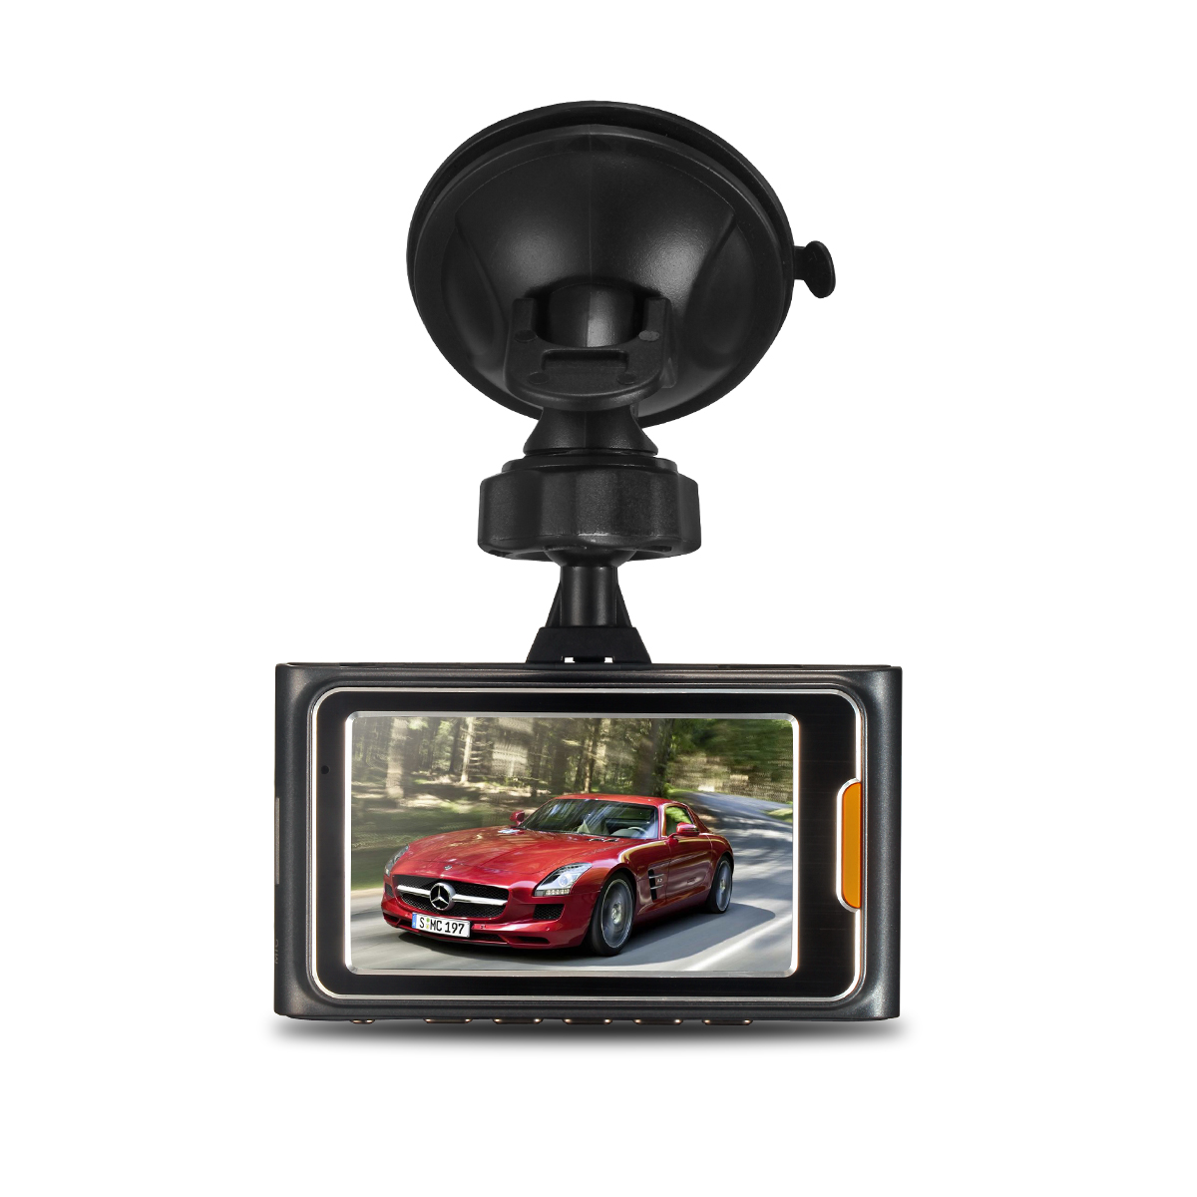

G95 Car DVR Camera supports Ambarella A7LA50 chipset plus OV4689 sensor, 4 mega pixel. It is a state-of-the-art dash cam that supports the 2560×1080 as well as the 1296p formats. It records very good video quality both at day and at night, and supports ADAS Calibration like LDWS, FCWS, PDSW, HBM, TSR, etc. If you are looking for great video footage at the highest resolutions available with ADAS included in 2015, go for this one.
This Cam is great aid for driving and proves their worth in many different situations. They could record your memorable precious moments of your life and those recorded videos could also prove great evidence for some undesirable happenings .This camera records in a continuous loop so you could never miss a thing but the G-Sensor helps this device to save those important files from being overwritten which has recorded some important information and this Car DVR always protecting you when driving anywhere at anytime.
This little device gives you big peace of mind and security of your Car.
Glossary :
ADAS : Advanced Driver Assitance System
LDWS: Lane Departure Warning System
FCWS: Forward Collision Warning System
PDSW: Pedestrian Detection System
HBM: High Beam Assist
TSR: Traffic Sign Recognition
Main Features:
170 degree super wide angle lens.
2304*1296/30fps high definition resolution.
Advanced H.264 video compression technology.
2.7 inch high resolution LCD
Support HDMI high quality video transmission.
G-Sensor protect the important from being overwritted
Loop recording function
Automatic circulating recording, it’s able to set the record time for each file.
Watching video simultaneous while driving, supporting on-spot play back.
Time & date display changed, there is no need to reset when re-starts.
A key to lock function
Motion detection function
Automatically turn on/off function
Can charge and transmission through USB.
Equipped with special car fixed sucker, easy to fix and use.
Maximum memory storage 32GB, or TF with more high capacity storage device.

Specifications
Chipset | Ambarella A7LA50
Sensor | 5.0 MP COMS
Screen Size | 2.7 Inch TFT LCD Screen
Color | Dark grey
Lens Angle | 170 degree wide angle lens
HDR Function | YES
Aperture Range | F1.8
Focal Distance | f=2.8mm
Decode Format | H.264
Video Resolution | 2560*1080P(30fps)/2304*1296P(30fps)  1920*1080P(30fps)/HDR 1920*1080P(30fps)  1280*720P(60fps)/1280*720P(30fps)
Video Format | MOV
Photo Resolution | 16M(5312*2988) 13M(4800*2700) 9M(4000*2250) 4M(2688*1512)
Photo Format | JPG
G-Sensor | YES
Screen Resolution | 960*240
Loop-cycle recording | Off/1min/3min/5min
Frequency | 50HZ/60HZ
TV mode | PAL/NTSC
HDMI output | YES
Language | English/Simplified Chinese/Traditional Chinese/ Russian/Polish/Dutch/Czech/Deutsch/French
Time Stamp | YES
Auto-Power On | YES
Auto-Power OFF | OFF/1min/3min/5min
Delay Shutdown | OFF/15sec/30sec/1min
Microphone | YES
AV interface | AV-OUT Mini HDMI
Data interface | Mini-USB
Working voltage | DC 12~24V
Power Interface | 5V 1.5A
Storage Expansion | TF Card up to 32G
Battery | Lithium battery 150mAH
Product weight | 70g
Package weight | 355g
Product size(L*W*H) | 8.7*5.2*3.8cm
Package size(L*W*H) | 17.5*13.5*8.5cm

